

**Software Requirements**

**Specification (SRS)**

MailSpeak Application (MSA)

University of Maryland Global Campus (UMGC)

Software Engineering (SWEN) 670

Fall Cohort 2022

Team B

November 5, 2022

**Document Control**

**Document Information**

|  |  |
| --- | --- |
| **©** | **Information** |
| Document Identification | USPS- MSA-SRS-20220903-Fall2022 |
| Document Owner | UMGC SWEN 670 |
| Issue Date | September 3, 2022 |
| Last Saved Date | November 5, 2022 |
| File Name | SRS-Team B-MSA.docx |

**Document History**

|  |  |  |
| --- | --- | --- |
| **Version** | **Issue Date** | **Changes** |
| 0.1 | 9/1/2022 | Initial Draft |
| 0.2 | 9/3/2022 | Review Updates |
| 1.0 | 9/3/2022 | Final Deliverable |
| 1.1 | 9/15/2022 | Add Project Suite of Documents |
| 2.0 | 9/17/2022 | Final Deliverable |
| 2.1 | 10/7/2022 | Logo and name change updates |
| 3.0 | 10/29/2022 | Post-development updates |
| 3.1 | 10/30/2022 | References style and document suite updates |
| 3.2 | 11/4/2022 | Use cases updates |
| 4.0 | 11/5/2022 | Final deliverable |

Approval Signatures

|  |  |  |  |  |
| --- | --- | --- | --- | --- |
| ☐ APPROVE  ☐ DISAPPROVE | |  | | --- | |  | | Tatiana Kozhevnikova, Product Owner  Date: _____________ | |  | |
| ☐ APPROVE  ☐ DISAPPROVE | |  | | --- | |  | | Michael Conatser, Project Manager  Date: _____________ | |

**Table of Contents**

1 Introduction 5

1.1 Purpose 5

1.2 Scope 5

1.3 Definitions, Acronyms and Abbreviations 5

1.4 Project Documentation 6

1.4.1 Project Suite of Documents 6

1.4.2 Document References 6

1.5 Overview 6

2 Overall Description 6

2.1 Use-Case Model Survey 7

2.2 Use Case Diagrams 9

2.3 Assumptions and Dependencies 16

2.3.1 Assumptions 16

2.3.2 Dependencies 16

3 Specific Requirements 16

3.1 Use-Case Reports 16

3.1.1 Feature Area: Search 16

3.1.2 Feature Area: Chatbot 22

3.1.3 Feature Area: Gesture 26

3.1.4 Feature Area: Voice Driven 28

3.1.5 Feature Area: Reading Mode 51

3.2 Supplementary Requirements 53

3.3 Supporting Information 53

3.4 Scan 53

# Introduction

The United States Postal Service (USPS) is an agency that transports mail to and from residential and commercial customers. To better assist their customers, the USPS offers a free subscription service called Informed Delivery that allows users to receive images of the mail incoming 7 days a week. The service even allows senders of mail items to associate advertisements via their campaign feature, replace black and white images of mail with full-color photos, and show packages arriving within the next week, as well as outbound.

To extend the Informed Delivery service’s capabilities, USPS has requested a set of features to be implemented via an external application that will allow customers to be able to consume and interact with this service even further. The application is meant to run on mobile devices and will allow the use of voice commands to find mail items, as well as to trigger alerts when items are received. Overall, the application should focus on enabling users with visual impairments to more effectively achieve their goals than by using a standard email client.

## Purpose

The purpose of the SRS is to identify succinct and thorough documentation through textural Use Cases and Use Case diagrams. This document will be used by the Informed Delivery Team B project team to build and deploy by November 2022.

The application will implement several modules outside of the scope of this document. The Use Cases for the modules implemented in this document are shown in depth in Section 3. Below provides a summary of the primary functional areas that will be addressed by Use Cases in this document:

1. Search – Enhance search capabilities by providing a filter for past emails using specific date range and keyword
2. Chatbot – Enhance functionality to provide a better user experience
3. Gesture Input – Implement enhanced gesture input capabilities
4. Voice Input – Implement voice driven function for application functions
5. Screen Reader – Enhance efficacy of screen reader functionality

## Scope

The application under development is a mobile application that has been created to be used in conjunction with USPS Informed Delivery service to provide visually impaired and sighted users access to the service with accessibility features. The features will enhance the pre-existing text-to-talk and voice input functionality already implemented in the application and will provide enhanced searching capabilities to allow for better navigation and organization of emails. There will also be significant enhancement to better implement the Chatbot implementation to provide a more interactive experience to the user.

## Definitions, Acronyms and Abbreviations

Throughout this document there are many common terms that relate to the application being created. However, to provide additional clarity all terms related to the application are defined below:

1. AI – Artificial Intelligence
2. Email – Electronic mail; Messages exchanged over a digital network
3. MSM – Mail Speak Application
4. IMAP – Internet Message Access Protocol
5. Inbox – A system component which stores the user’s received emails
6. SRS – Software Requirements Specification
7. TBD – To Be Determined
8. UI – User Interface
9. USPS – United States Postal Service

## Project Documentation

### Project Suite of Documents

This Software Requirements Specification is part of a set of essential documents created to adequately manage, control and deliver the USPS Informed Delivery Application. Artifacts that are provided within the document package contain vital information for the application’s ongoing support and operation throughout its life cycle. Each document is created within the specific Milestone of the project.

Table . –Project Documentation Package

| Document | Version | Date |
| --- | --- | --- |
| Project Management Plan | 4.0 | 11/05/2022 |
| Software Requirements Specification | 4.0 | 11/05/2022 |
| Technical Design Document | 3.0 | 11/05/2022 |
| Software Test Plan | 3.0 | 11/05/2022 |
| Programmer Guide | 2.0 | 11/05/2022 |
| Development and Operations Guide | 2.0 | 11/05/2022 |
| User Guide | 1.0 | 11/05/2022 |
| Test Report | 1.0 | 11/05/2022 |

### Document References

During the process of writing current SRS the following documents were referenced:

* Team B. (2022). *United Global Master Coders Team B Project Management Plan*. <https://umgcdev361.sharepoint.com/:w:/r/sites/SWEN670Fall2022/Shared%20Documents/Team%20B%20Channel/Milestone%201%20(SAT%20SEP%203)/ProjectManager-Project-Plan-Template.docx?d=w671384dfe89d46d7a2583b60416fb909&csf=1&web=1&e=xeRN2o>
* University of Maryland Global Campus (UMGC). (2022) *SWEN 670 capstone project management system*. <https://umgc-cappms.azurewebsites.net/download/48433bae-ed2e-4593-9285-80715ad69039----Team-A-SoftwareRequirementSpecification.docx>

## Overview

This SRS is divided into two relevant sections: Overall Description and Specific Requirement. Overall Description will define the requirements at a high level, while Specific Requirements describe in detail the modules to be covered by this document.

# Overall Description

The USPS Informed Delivery application provides users access to emails stored in the inboxes of their email accounts, with specific attention given to emails received through the USPS Informed Delivery service. The application places emphasis on accessibility for the visually impaired through the utilization of text-to-speech and speech-to-text functionality.

The enhancements to the informed delivery application that are to be implemented in the course of this project will extend the product’s current functionality. These enhancements will provide users with more powerful email search functionality, enhanced usability (with visually impaired users as the primary focus), and user behaviour reporting.

## Use-Case Model Survey

There are 37 Use Cases that make up the requirements for the specified functionality. The detailed Use Cases are identified in section 3.

Table . - Use Cases Overview

| **Use Case** | **Description** |
| --- | --- |
| 1. Search past emails using specific date range and keyword | Searches inbox for emails that were sent within a given date range and contain a given keyword |
| 2. Chatbot: Initial chat suggestions | Chatbot provides the user with suggested commands |
| 3. Chatbot: Request help documentation | Chatbot provides the user with access to help documentation |
| 4. Chatbot: Adding notifications | Chatbot allows the user to add new notifications |
| 5. Chatbot: Removing notifications | Chatbot allows the user to remove notifications |
| 6. Chatbot: Search mail by name | Chatbot allows the user to search for emails sent by a given sender |
| 7. Chatbot: Search mail by specific date | Chatbot allows the user to search for emails sent on a given date |
| 8. Chatbot: Search mail by specific date range | Chatbot allows the user to search for emails sent within a given date range |
| 9. Gesture: Right swipe | Navigates application |
| 10. Gesture: Right swipe from far left | Navigates back to previous page |
| 11. Gesture: Left swipe | Navigates application |
| 12. Gesture: Tap out | Dismisses subscreen |
| 13. Voice Driven: Login | Logs into application |
| 14. Voice Driven: Show Menu | Shows top bar menu |
| 15. Voice Driven: Show Menu - Settings | Opens settings |
| 16. Voice Driven: Show Menu - Logout | Logs out from application |
| 17. Voice Driven: Open Search Mail | Opens mail search |
| 18. Voice Driven: Search Mail | Searches for mail |
| 19. Voice Driven: Search Mail: Open Individual Mail Piece | Opens individual mail piece |
| 20. Voice Driven: Open Notifications | Opens notifications |
| 21. Voice Driven: Add Notification | Adds new notification subscription |
| 22. Voice Driven: Delete Notification | Deletes existing notification subscription |
| 23. Voice Driven: Open Chatbot | Opens chat support |
| 24. Voice Driven: Chatbot Commands | Executes chatbot commands |
| 25. Voice Driven: Open Settings | Opens Settings |
| 26. Voice Driven: Settings – View “Terms and Conditions” | Opens “Terms and Conditions” dialog |
| 27. Voice Driven: Settings – View “Privacy Policy” | Opens “Privacy Policy” |
| 28. Voice Driven: Dismiss Dialog | Dismisses dialog pop-up |
| 29. Voice Driven: Open Daily Digest | Opens daily digest |
| 30. Voice Driven: Daily Digest – View Next Mail Piece | Opens next mail piece |
| 31. Voice Driven: Daily Digest – View Previous Mail Piece | Opens previous mail piece |
| 32. Voice Driven: Open Upload Mail | Opens upload mail (photo gallery) |
| 33. Voice Driven: Open Scan Mail | Opens scan mail (camera) |
| 34. Voice Driven: Home Action/ Main Menu | Opens main menu |
| 35. Voice Driven: Back Action | Navigates to previous screen |
| 36. Reading Mode: Whole Screen | Native OS text-to-speech reading of whole screen |
| 37. Reading Mode: Single User Interface (UI) Element | Native OS text-to-speech reading of single UI element |

## Use Case Diagrams

* **Search Past Emails**

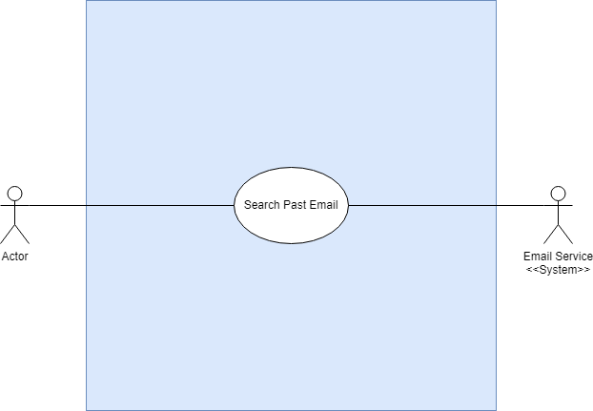

2Figure . - Search Past Emails System

**Description:**

This Use Case diagram describes the functionality available for the Search Past Emails feature within the application.

**Use Cases:**

1. Search past emails using specific date range and keyword or sender and mail body text keywords

**Primary Actor:**

User –user of the application.

**Supporting Actors:**

Email Service – User's email service provider

**Stakeholders and Interests:**

User desires to search emails in their inbox.

**Pre-Conditions:**

User must have an operational email account that is accessible through the application and must be logged into the application.

**Post Conditions:**

User is on the list of filtered emails page until they press the back action. Search criteria will stay until the user clears it or closes the application.

**Minimal Guarantee:**

User is provided with a view of emails that match the given search criteria.

**Main Success Scenario:**

1. User is able to input date range or keyword into search.
2. User is able to select “Search”.
3. User is presented with a filtered view of emails from local storage that match the search criteria.

**Extensions:**

1a. User is able to select the “Advanced Search” option.

1b. User is able to input date range, sender keyword, and mail body keyword.

* **Chatbot**

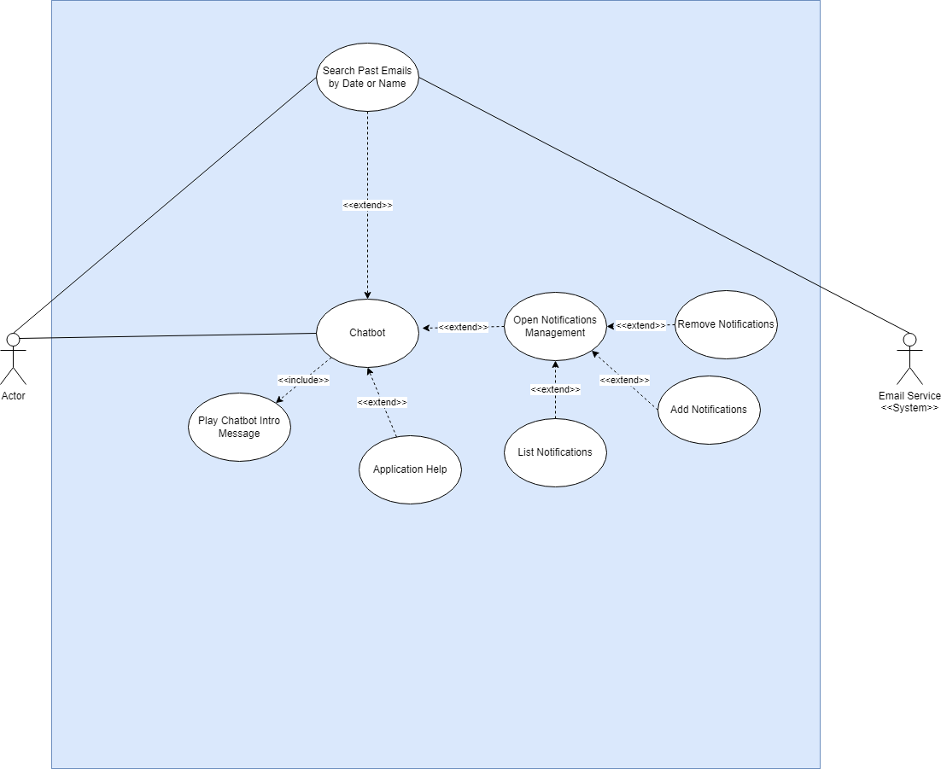

Figure . - Chatbot System

**Description:**

This Use Case diagram describes the functionality available for the Chatbot feature within the application.

**Use Cases:**

1. Initial Chat Suggestions
2. Request Help Documentation
3. Adding Notifications
4. Removing Notifications
5. Search Mail by Name
6. Search Mail by Specific Date
7. Search Mail by Specific Date Range

**Primary Actor:**

User –user of the application.

**Supporting Actors:**

Email Service – User's email service provider

**Stakeholders and Interests:**

User desires to use chatbot for information and notification settings management.

**Pre-Conditions:**

User must be logged into the application and have Chatbot open.

**Post Conditions:**

User has been presented with desired information or has successfully managed notification settings.

**Minimal Guarantee:**

User is able to retrieve desired information or successfully manage notification settings through Chatbot.

**Main Success Scenario:**

1. User opens Chatbot.
2. User requests help documentation.
3. Chatbot with help documentation link.
4. User requests a notification be added.
5. Notification is added to active notifications.
6. User requests a notification be removed.
7. Notification is removed from active notifications.
8. User searches emails by name.
9. User is presented with emails sent by the given name.
10. User searches emails by date.
11. User is presented with emails sent on given date.
12. User searches emails by date range.
13. User is presented with emails sent within the given date range.

**Extensions:**

6a. No notification found.

6b. Notification is already active.

8a. No notification found.

8b. Notification is not active.

* **Gesture**

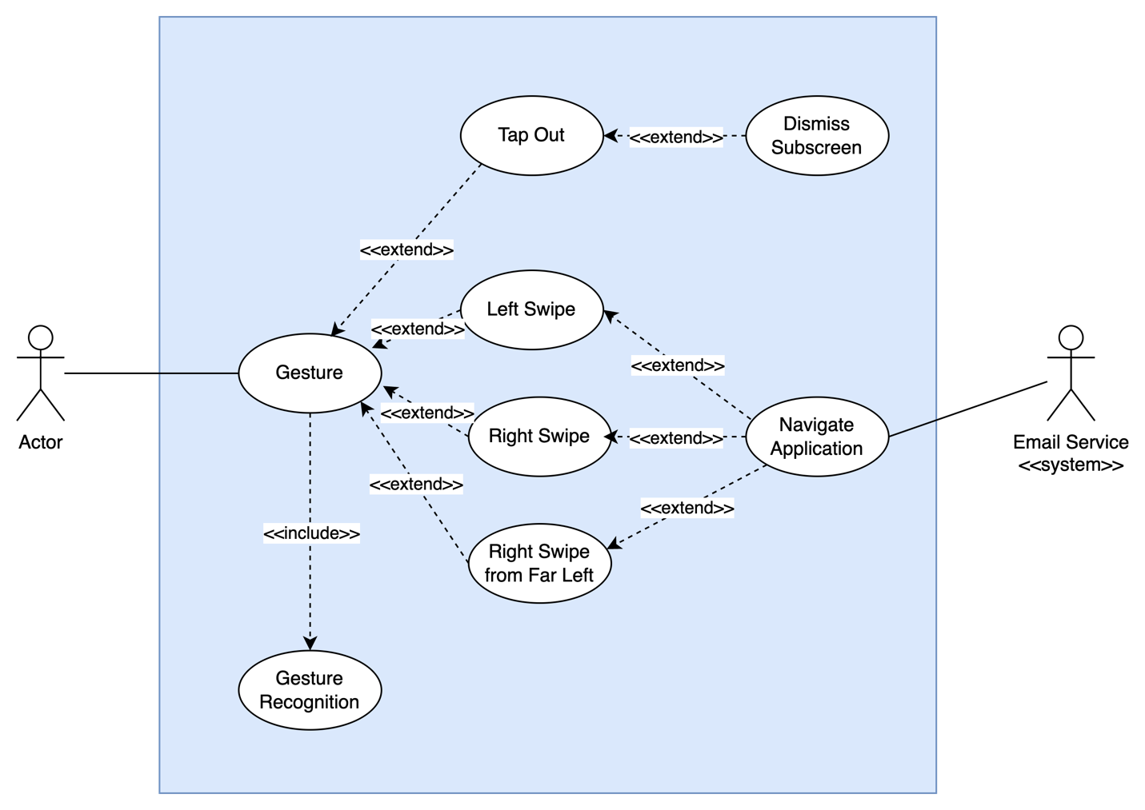

Figure . - Gesture System

**Description:**

This Use Case diagram describes the functionality available for the gesture driven commands feature.

**Use Cases:**

1. Hold Down
2. Left Swipe
3. Right Swipe
4. Right Swipe from Far Left
5. Tap Out

**Primary Actor:**

User –user of the application.

**Supporting Actors:**

Email Service – User's email service provider

**Stakeholders and Interests:**

User desires to navigate application using gestures.

**Pre-Conditions:**

User must have an operational email account that is accessible through the application and must be logged into the application.

**Post Conditions:**

User successfully navigates to area of application, or subscreens are dismissed.

**Minimal Guarantee:**

User is able to perform actions using gestures.

**Main Success Scenario:**

1. User is able to input gesture.
2. User navigates to mail view
3. User swipes right.
4. User navigates to next mail piece.
5. User swipes left.
6. User navigates to previous mail piece.
7. User taps out.
8. Any subscreen is dismissed.
9. User swipes right from far left edge of screen
10. Application navigates back to previous page

* **Voice Driven**

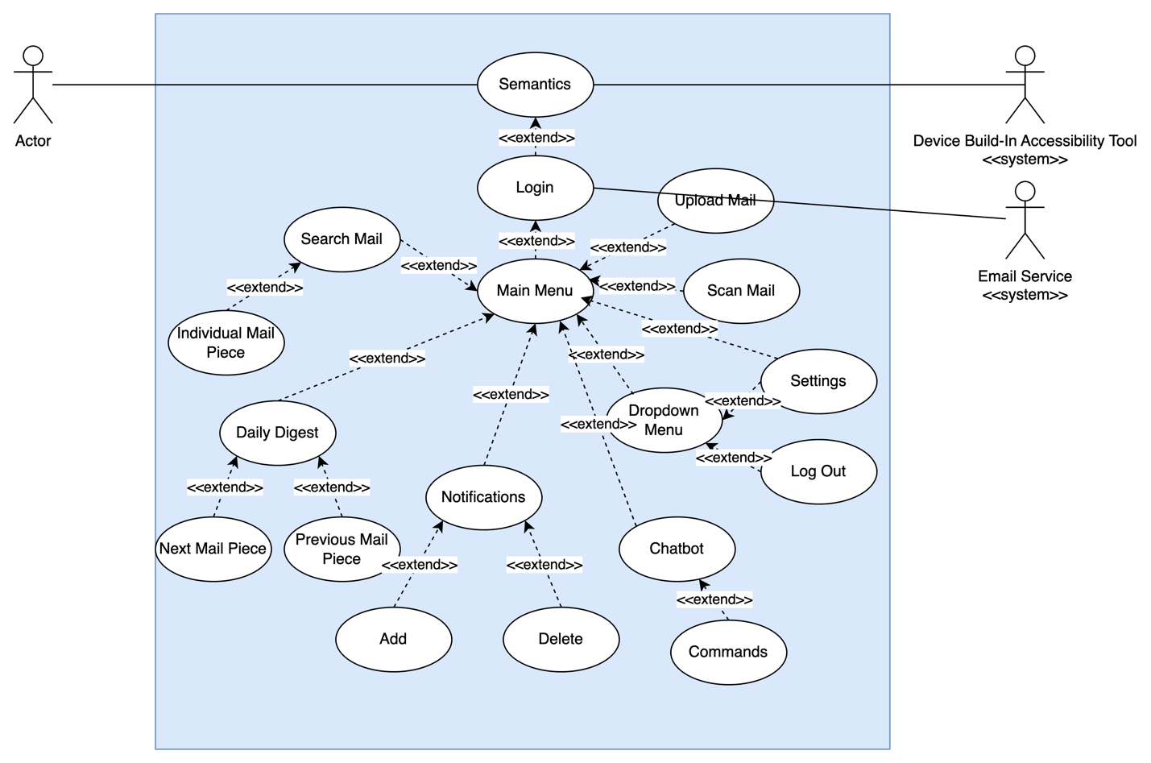

Figure . - Voice Driven System

**Description:**

This Use Case diagram describes the functionality available for the Voice Driven feature within the application.

**Use Cases:**

1. Login
2. Show Menu
3. Show Menu – Settings
4. Show Menu – Logout
5. Open Search Mail
6. Search Mail
7. Search Mail with Filter
8. Search Mail – Open Individual Mail Piece
9. Open Notifications
10. Add Notification
11. Delete Notification
12. Open Chatbot
13. Chatbot Commands
14. Open Settings
15. Settings – View “Terms and Conditions”
16. Settings – View “Privacy Policy”
17. Dismiss Dialog
18. Open Daily Digest
19. Daily Digest – View Next Mail Piece
20. Daily Digest – View Previous Mail Piece
21. Open Upload Mail
22. Open Scan Mail
23. Home. Action/ Main Menu
24. Back Action
25. **Primary Actor:**

User –user of the application.

**Supporting Actors:**

Email Service – User's email service provider

Device Build-in Accessibility Tool – Enables input of voice commands

**Stakeholders and Interests:**

User desires to navigate application and perform actions using voice commands.

**Pre-Conditions:**

User must have an operational email account that is accessible through the application. User must have internet connection. User must enable accessibility mode for voice commands on their Android/iOS device.

**Post Conditions:**

User has successfully navigated to the desired area of the application or has performed the desired action.

**Minimal Guarantee:**

User is able navigate the application and perform actions using voice commands.

**Main Success Scenario:**

1. User logs in.
2. User opens top bar dropdown menu.
3. User selects “Settings” in the top bar dropdown menu.
4. User selects “Logout” top bar dropdown menu.
5. User opens mail search
6. User searches for mail.
7. User opens individual mail piece.
8. User opens notifications.
9. User adds notification subscription.
10. User deletes notification subscription.
11. User opens chat support.
12. User communicates with chatbot via commands.
13. User opens settings.
14. User views “Terms and Conditions”.
15. User views “Privacy Policy”.
16. User dismisses dialog.
17. User opens daily digest.
18. User views next mail piece in daily digest.
19. User views previous mail piece in daily digest.
20. User opens upload mail.
21. User opens scan mail.
22. User sets navigates to main menu.
23. User sets navigates to previous screen.
24. **Extensions:**

1a. User logs in with Google account.

6a. User searches for mail with filters

* **Reading Mode**

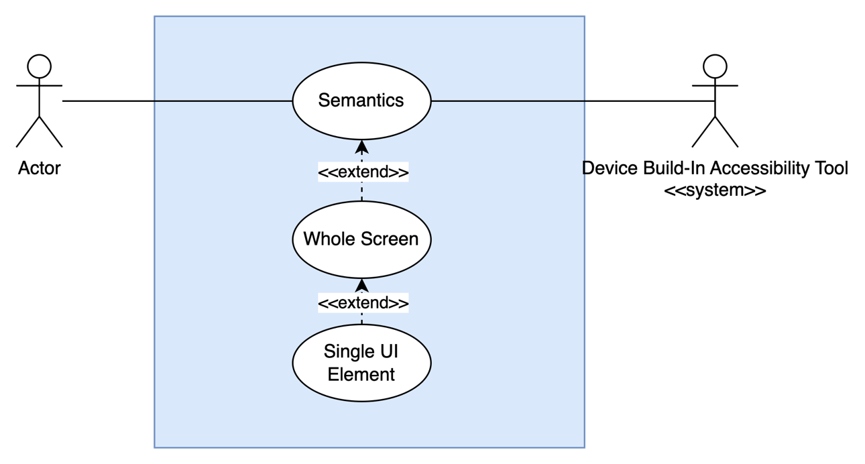

Figure . - Reading Mode

**Description:**

This Use Case diagram describes the functionality available for the Reading Mode feature within the application.

**Use Cases:**

1. Whole Screen
2. Single UI Element

**Primary Actor:**

User –user of the application.

**Supporting Actors:**

Device Build-in Accessibility Tool – Enables text-to-speech.

**Stakeholders and Interests:**

User desires to be provided with a text-to-speech translation of text currently in view.

**Pre-Conditions:**

User must have an operational email account that is accessible through the application. User must have device speakers enabled. User must enable accessibility mode for screen reading on their Android/iOS device.

**Post Conditions:**

N/A

**Minimal Guarantee:**

User is provided with an audio narration of current text in view within the application.

**Main Success Scenario:**

1. All elements on the screen are read by the build-in accessibility tool.
2. Single UI element is read by the build-in accessibility tool.

## Assumptions and Dependencies

### Assumptions

1. Users have access to a device that is capable of installing and running the application.
2. Users have access to a device that is capable of accessing the internet.
3. Email accounts with which the application is interfacing have Internet Message Access Protocol (IMAP) enabled and are operational.

### Dependencies

1. Access to email accounts through the application is dependent on the security policy of the organization that provides the email service.
2. Processing of images of mail pieces is dependent on the application’s ability to access the Google Cloud Vision AI (Artificial Intelligence) service.

# Specific Requirements

The Use Case Reports below will provide the details of the 37 Use Cases being implemented with this application. The following Use Cases will contain both internal and external pre and post conditions.

## Use-Case Reports

### Feature Area: Search

#### Use case name: Search past mail using specific date range and keyword

**Summary**: The application shall allow users to enter a date range and keyword to filter their mail by. The keyword shall look in all text fields stored in the mail piece record.

**Preconditions**:

1. The user must be logged in for the search inputs to appear.

**Triggers**: Entering dates or a keyword into the inputs and selecting Search to apply the filters and view the mail results

**Basic course of events (Scenario):**

*Internal Precondition:* User is logged in successfully with an active email address

| Actor | System | Screen |
| --- | --- | --- |
| 1. User selects a start and end date for the date range input. |  |  |
|  | 1. System displays date range. |  |
| 1. User enters keyword into input. |  |  |
|  | 1. System displays user’s entered keyword and presents a list of mail pieces that match the provided keyword. |  |
| 1. User selects the checkmark on-screen keyboard and selects the “Search” button. |  |  |
|  | 1. The system displays mail items meeting the search criteria. |  |

*Inter Post Condition:*

1. User is on the list of filtered mail pieces page until they press the back action
2. Search criteria will stay until the user clears it or closes the application

**Alternative Course of Events:**

1. **Advanced Search:**

|  |  |  |
| --- | --- | --- |
| Actor | System | Screen |
| 3. User selects the “Advanced Search” option. |  |  |
|  | 4. The sender and mail body text input controls are visible and the keyword input control is no longer visible. |  |
| 5. User enters text into the sender input control. |  |  |
|  | 6. System displays user’s entered keyword and presents a list of mail pieces that match the provided keyword. |  |
| 7. User selects the checkmark on the on-screen keyboard and enters text into the mail body input control. |  |  |
|  | 8. System displays user’s entered keyword and presents a list of mail pieces that match the provided keyword. |  |

### Feature Area: Chatbot

#### Use Case Name: Chatbot - Initial Chat Suggestions

**Summary:** The application shall provide an introductory message to the user.

**Preconditions:**

1. User must be logged in

**Triggers:** Opening the chat window with the chatbot shall start with printing out common commands.

**Basic course of events (Scenario):**

| Actor | System | Screen |
| --- | --- | --- |
| 1. User taps on the chatbot button. |  |  |
|  | 1. System opens the chat window with chatbot. |  |
|  | 1. System responds in the chat window with introductory message. |  |

#### Use Case Name: Chatbot - Request Help Documentation

**Summary:** The application shall allow the user to request help documentation from the chat bot window.

**Preconditions:**

1. User must be logged in
2. Chatbot window must be opened

**Triggers:** Entering in the chat with text phrase “help” shall bring a link to application help documentation

**Basic course of events (Scenario):**

| Actor | System | Screen |
| --- | --- | --- |
| 1. User types in “Help” into the chat bot window. |  |  |
| 1. User hits enter on their device’s keyboard. |  |  |
|  | 1. System responds in the chat window with a list of suggested commands. |  |

**Alternative Course of events:**

1. **Uses Chatbot Return Button:**

| Actor | System | Screen |
| --- | --- | --- |
| 1. User taps on the return button in the chatbot window. |  |  |

#### Use Case Name: Chatbot - Adding Notifications

**Summary:** The application shall allow adding of a notification and to be associated with logged in user.

**Preconditions:**

1. User must be logged in
2. Chatbot window must be opened

**Triggers:** User enters the text phrase “notifications add [input]” into the chatbot window.

**Basic course of events (Scenario):**

| Actor | System | Screen |
| --- | --- | --- |
| 1. User types in “notifications add [input]” into the chatbot window. |  |  |
| 1. User hits enter on their device’s keyboard. |  |  |
|  | 1. System responds with a message indicating that a notification has been added for the keyword that was input. |  |

**Alternative course of events:**

1. **Uses Chat Bot Return Button:**

| Actor | System | Screen |
| --- | --- | --- |
| 1. User taps on the return button in the chatbot window. |  |  |

#### Use Case Name: Chatbot - Removing Notifications

**Summary:** The application shall allow removal of a notification associated with the logged in user.

**Preconditions:**

1. User must be logged in
2. Chatbot window must be opened

**Triggers:** User enters the text phrase “notifications delete [input]” into the Chatbot window.

**Basic course of events (Scenario):**

| Actor | System | Screen |
| --- | --- | --- |
| 1. User types in “notifications delete [input]” into the chatbot window. |  |  |
| 1. User hits enter on their device’s keyboard. |  |  |
|  | 1. System respondswith a message indicating that the notification has been removed for the keyword that was input. |  |

**Alternative course of events:**

1. **Uses Chatbot Return Button:**

| Actor | System | Screen |
| --- | --- | --- |
| 1. User taps on the return button in the chatbot window. |  |  |

#### Use Case Name: Chatbot - Search Mail by Name

**Summary:** The application shall search for a specific mail sender by name.

**Preconditions:**

1. User must be logged in
2. Chatbot window must be opened

**Triggers:** User enters the text phrase “search” into the chatbot window.

**Basic course of events (Scenario):**

| Actor | System | Screen |
| --- | --- | --- |
| 1. User types in “search [input]” into the chatbot window. |  |  |
| 1. User hits enter on their device’s keyboard. |  |  |
|  | 1. System responds with listing all relevant mail with a sender or mail body text that matches the keyword that was input. |  |

**Alternative course of events:**

1. **Uses Chatbot Return Button:**

| Actor | System | Screen |
| --- | --- | --- |
| 1. User taps on the return button in the chatbot window. |  |  |

#### Use Case Name: Chatbot - Search Mail by Specific Date

**Summary:** The application shall search for mail by a specific date (singular day).

**Preconditions:**

1. User must be logged in
2. Chatbot window must be opened

**Triggers:** User enters the text phrase “search” into the chatbot window.

**Basic course of events (Scenario):**

| Actor | System | Screen |
| --- | --- | --- |
| 1. User types in “search [date]” into the chatbot window. |  |  |
| 1. User hits enter on their device’s keyboard. |  |  |
|  | 1. System responds by listing all mail that was received on the given date. |  |

**Alternative course of events:**

1. **Uses Chatbot Return Button:**

| Actor | System | Screen |
| --- | --- | --- |
| 1. User taps on the return button in the chatbot window. |  |  |

1. **Cannot Find Mail by Date:**

| Actor | System | Screen |
| --- | --- | --- |
|  | 1. System responds with cannot find mail associated with the given date. |  |

#### Use Case Name: Chatbot - Search Mail by Specific Date Range

**Summary:** The application shall search for mail sent in a date range.

**Preconditions:**

1. User must be logged in
2. Chatbot window must be opened

**Triggers:** User enters the text phrase “search” into the chatbot window.

**Basic course of events (Scenario):**

| Actor | System | Screen |
| --- | --- | --- |
| 1. User types in “search [start date] [end date]” into the chatbot window. |  |  |
| 1. User hits enter on their device’s keyboard. |  |  |
|  | 1. System responds by listing all mail that was received within the given date range. |  |

**Alternative course of events:**

1. **Uses Chatbot Return Button:**

| Actor | System | Screen |
| --- | --- | --- |
| 1. User taps on the return button in the chatbot window. |  |  |

1. **Cannot Find Mail by Date:**

| Actor | System | Screen |
| --- | --- | --- |
|  | 1. System responds with cannot find mail associated with given date range. |  |

### Feature Area: Gesture

#### Use Case Name: Gesture -- Right Swipe

**Summary**: The application shall respond to the user pressing a finger to the left side of the screen and moving the finger to the right.

**Preconditions**:

1. User device is touch screen enabled.
2. The current screen is an Individual Mail/Daily Digest screen.

**Triggers**: User presses finger to the left side of the screen or sub screen and moves the finger to the right.

**Basic course of events:**

| Actor | System | Screen |
| --- | --- | --- |
| 1. User presses a finger on the left side of the screen within the display and moves the finger to the right. |  |  |
|  | 1. System changes screen to the mail one (1) position down from the currently viewed in the list. |  |

*Inter Post Condition:*

1. System remains upon screen until acted upon by user.

#### Use Case Name: Gesture – Swipe Right from Far Left

**Summary**: The application shall respond to the user pressing a finger to the far left edge of the screen and moving the finger to the right.

**Preconditions**:

1. User device is touch screen enabled.
2. The current screen or sub screen element of the system is one of the following:
   1. Mail Search, Search Results, Individual Mail Piece, Daily Digest, Chatbot, Notification, Settings

**Triggers**: User presses finger to the left edge of the screen or sub screen and moves the finger to the right.

**Basic course of events:**

| Actor | System | Screen |
| --- | --- | --- |
| 1. User presses a finger to the left edge of the screen and moves the finger to the right. |  |  |
|  | 1. System returns screen to the previously visited screen. |  |

#### Use Case Name: Gesture – Left Swipe

**Summary**: The application shall respond to a user pressing a finger to the right side of a screen or sub screen and moving finger to the left when viewing emails.

**Preconditions:**

1. User device is touch screen enabled.
2. The current screen is an Individual Mail/Daily Digest screen.

**Triggers**: User presses a finger to the right side of the screen or sub screen and moves the finger to the left.

**Basic course of events (Email View Screen - When Not First Email in List):**

| Actor | System |
| --- | --- |
| 1. User presses finger on the right side of the screen within the display and moves the finger to the left. |  |
|  | 1. System changes screen to the mail one (1) position up from the currently viewed in the list. |

#### Use Case Name: Gesture - Tap Out

**Summary**: The application shall respond to a user tapping outside of an active sub screen element by dismissing sub screen and refocusing upon the underlying screen.

**Preconditions**:

1. User device is touch screen enabled.
2. An active sub screen is present.

**Triggers**: User taps screen outside of an active sub screen.

**Basic Course of Events (Scenario):**

| Actor | System |
| --- | --- |
| 1. User taps screen outside of active sub screen. |  |
|  | 1. System dismisses sub screen and refocuses upon underlying screen. |

### Feature Area: Voice Driven

#### Use Case Name: Voice Driven – Login

**Summary**: User logs in by filling out login form or logs in using Google account.

**Preconditions**:

1. User has “Voice Access” (Android)/ “Voice Control” (iOS) enabled.
2. The app is open on the Login screen.

**Triggers**: User opened MailSpeak application.

**Basic Course of Events:**

| Actor | System |  |
| --- | --- | --- |
| 1. User says “Tap E-Mail Address”. |  |  |
|  | 1. System enters text editing mode in the “E-Mail Address” text field. |  |
| 1. User populates “E-Mail Address” text field. |  |  |
|  | 1. System exits text editing mode and email is displayed. |  |
| 1. User says “Tap Password Address”. |  |  |
|  | 1. System enters text editing mode in the “Password” text field. |  |
| 1. User populates “E-Mail Address” text field. |  |  |
|  | 1. System exits text editing mode and password is displayed as masked value. |  |
| 1. User says “Tap Conditions”. |  |  |
|  | 1. System displays “Conditions” checkbox as checked |  |
| 1. User says “Tap RETRIEVE MAIL” |  |  |
|  | 1. System performs credential validation |  |
|  | 1. System performs email cashing process |  |
|  | 1. System displays “Main Menu” |  |

**Alternative course of events:**

1. **Login with Google Account:**

| Actor | System | Screen |
| --- | --- | --- |
| 1. User says “Tap Conditions”. |  |  |
|  | 1. System displays “Conditions” checkbox as checked |  |
| 1. User says “Google Sign-In” |  |  |
|  | 1. System displays Google form to sign in |  |
| 1. User completes form |  |  |
|  | 1. System performs credential validation |  |
|  | 1. System performs email cashing process |  |
|  | 1. System displays “Main Menu” |  |

#### Use Case Name: Voice Driven – Show Menu

**Summary**: Top bar dropdown menu is displayed.

**Preconditions**:

1. User has “Voice Access” (Android)/ “Voice Control” (iOS) enabled.
2. User logged in.

**Triggers**: User taps “Show Menu” button in the top bar.

**Basic Course of Events:**

| Actor | System |  |
| --- | --- | --- |
| 1. User says “Tap Show Menu”. |  |  |
|  | 1. System displays top bar dropdown menu. |  |

*Inter Post Condition:*

1. Dropdown menu is displayed until option is selected or menu is dismissed.

#### Use Case Name: Voice Driven – Show Menu: Settings

**Summary**: User selects “Settings” option in the top bar dropdown menu.

**Preconditions**:

1. User has “Voice Access” (Android)/ “Voice Control” (iOS) enabled.
2. User logged in.
3. Top bar dropdown menu is displayed.

**Triggers**: User taps “Settings” button in the top bar dropdown menu.

**Basic Course of Events:**

| Actor | System |  |
| --- | --- | --- |
| 1. User says “Tap Settings”. |  |  |
|  | 1. System displays “Settings” Screen. |  |

#### Use Case Name: Voice Driven – Show Menu: Logout

**Summary**: User selects “Logout” option in the top bar dropdown menu.

**Preconditions**:

1. User has “Voice Access” (Android)/ “Voice Control” (iOS) enabled.
2. Top bar dropdown menu is displayed.

**Triggers**: User taps “Logout” button in the top bar dropdown menu.

**Basic Course of Events:**

| Actor | System |  |
| --- | --- | --- |
| 1. User says “Tap Logout”. |  |  |
|  | 1. System displays “Logout” Screen. |  |

#### Use Case Name: Voice Driven – Open Search Mail

**Summary**: User opens “Mail Search” screen.

**Preconditions**:

1. User has “Voice Access” (Android)/ “Voice Control” (iOS) enabled.
2. User is logged in.

**Triggers**: User taps “Search” button on the “Main Menu” Screen or in the bottom bar.

**Basic Course of Events:**

| Actor | System |  |
| --- | --- | --- |
| 1. User says “Tap Search Mail” |  |  |
|  | 1. System displays “Mail Search” Screen. |  |

#### Use Case Name: Voice Driven – Search Mail with Filter

**Summary**: User performs mail search.

**Preconditions**:

1. User has “Voice Access” (Android)/ “Voice Control” (iOS) enabled.
2. User is logged in.
3. “Search Mail” screen is open.

**Triggers**: User taps “Search” button.

**Basic Course of Events (no fields are populated):**

| Actor | System |  |
| --- | --- | --- |
| 1. User says “Tap Search” |  |  |
|  | 1. System displays “Search Results” Screen. |  |

**Alternative course of events:**

1. **Search filter fields are populated:**

| Actor | System | Screen |
| --- | --- | --- |
| 1. User says “Tap Keyword”. |  |  |
|  | 1. System enters text editing mode in the “Keyword” text field. |  |
| 1. User populates “Keyword” text field. |  |  |
|  | 1. System exits text editing mode and keyword is displayed. |  |
| 1. User says “Tap Search” |  |  |
|  | 1. System displays “Search Results” Screen. |  |

*Inter Post Condition:*

1. Search results displayed according to search criteria.

#### Use Case Name: Voice Driven – Search Mail: Open Individual Mail

**Summary**: User views individual mail piece.

**Preconditions**:

1. User has “Voice Access” (Android)/ “Voice Control” (iOS) enabled.
2. User is logged in.
3. “Search Results” screen is open.
4. Search results are not empty

**Triggers**: User taps individual mail piece in the list.

**Basic Course of Events:**

| Actor | System |  |
| --- | --- | --- |
| 1. User says “Tap Letter from <sender> received on <date(EEE MMM dd)>” |  |  |
|  | 1. System displays “Mail Piece” Screen. |  |

#### Use Case Name: Voice Driven – Open Notifications

**Summary**: User opens “Notifications” screen.

**Preconditions**:

1. User has “Voice Access” (Android)/ “Voice Control” (iOS) enabled.
2. User is logged in.

**Triggers**: User taps “Notifications” button on the “Main Menu” Screen or in the bottom bar.

**Basic Course of Events:**

| Actor | System |  |
| --- | --- | --- |
| 1. User says “Tap Notifications” |  |  |
|  | 1. System displays “Notifications” Screen. |  |

*Inter Post Condition:*

1. List of notifications according to subscriptions is displayed.

#### Use Case Name: Voice Driven – Add Notification

**Summary**: User adds notification subscription.

**Preconditions**:

1. User has “Voice Access” (Android)/ “Voice Control” (iOS) enabled.
2. User is logged in.
3. “Notification” screen is open.

**Triggers**: User taps “Manage” tab on “Notification Screen”.

**Basic Course of Events:**

| Actor | System | Screen |
| --- | --- | --- |
| 1. User says “Tap Keyword”. |  |  |
|  | 1. System enters text editing mode in the “Keyword” text field. |  |
| 1. User populates “Keyword” text field. |  |  |
| 1. User says “Tap Add” |  |  |
|  | 1. Systems adds notification subscriptions to database. |  |
|  | 1. System displays new notification subscription on the screen withing notifications list. |  |

#### Use Case Name: Voice Driven – Delete Notification

**Summary**: User deletes notification subscription.

**Preconditions**:

1. User has “Voice Access” (Android)/ “Voice Control” (iOS) enabled.
2. User is logged in.
3. “Notification” screen is open.

**Triggers**: User taps “Manage” tab on “Notification Screen”.

**Basic Course of Events:**

| Actor | System | Screen |
| --- | --- | --- |
| 1. User says “Tap Delete <notification name>” |  |  |
|  | 1. System removes notification subscription from database. |  |
|  | 1. System removes notification from the notifications list on the screen. |  |

#### Use Case Name: Voice Driven – Open Chatbot

**Summary**: User opens “Chat Support” screen.

**Preconditions**:

1. User has “Voice Access” (Android)/ “Voice Control” (iOS) enabled.
2. User is logged in.

**Triggers**: User taps “Chatbot” button in the bottom bar.

**Basic Course of Events:**

| Actor | System |  |
| --- | --- | --- |
| 1. User says “Tap Chatbot” |  |  |
|  | 1. System displays “Chat Support” Screen. |  |

#### Use Case Name: Voice Driven – Chatbot Commands

**Summary**: User communicates with chatbot through commands.

**Preconditions**:

1. User has “Voice Access” (Android)/ “Voice Control” (iOS) enabled.
2. User is logged in.
3. “Chat Support” screen is open.

**Triggers**: User taps “Send” button

**Basic Course of Events:**

| Actor | System | Screen |
| --- | --- | --- |
| 1. User says “Tap Message”. |  |  |
|  | 1. System enters text editing mode in the “Message” text field. |  |
| 1. User populates “Message” text field. |  |  |
| 1. User says “Tap Send |  |  |
|  | 1. System processes user-specified command. |  |
|  | 1. System displays response to command. |  |

*Inter Post Condition:*

1. Command-specific response is displayed or redirection to specified screen is performed.

#### Use Case Name: Voice Driven – Open Settings

**Summary**: User opens “Settings” screen.

**Preconditions**:

1. User has “Voice Access” (Android)/ “Voice Control” (iOS) enabled.
2. User is logged in.

**Triggers**: User taps “Settings” button on the “Main Menu” Screen or in the bottom bar.

**Basic Course of Events:**

| Actor | System |  |
| --- | --- | --- |
| 1. User says “Tap Settings” |  |  |
|  | 1. System displays “Settings” Screen. |  |

#### Use Case Name: Voice Driven – Settings: View “Terms and Conditions”

**Summary**: User views “Terms and conditions”.

**Preconditions**:

1. User has “Voice Access” (Android)/ “Voice Control” (iOS) enabled.
2. User is logged in.
3. “Settings” screen is open.

**Triggers**: User taps “Terms and Conditions” button

**Basic Course of Events:**

| Actor | System | Screen |
| --- | --- | --- |
| 1. User says “Tap Terms and Conditions”. |  |  |
|  | 1. System displays “Terms and Conditions” dialog. |  |

#### Use Case Name: Voice Driven – Settings: View “Privacy Policy”

**Summary**: User views “Privacy Policy”.

**Preconditions**:

1. User has “Voice Access” (Android)/ “Voice Control” (iOS) enabled.
2. User is logged in.
3. “Settings” screen is open.

**Triggers**: User taps “Privacy Policy” button

**Basic Course of Events:**

| Actor | System | Screen |
| --- | --- | --- |
| 1. User says “Tap Privacy Policy”. |  |  |
|  | 1. System displays “Privacy Policy” dialog. |  |

#### Use Case Name: Voice Driven – Dismiss Dialog

**Summary**: User dismisses dialog pop-up.

**Preconditions**:

1. User has “Voice Access” (Android)/ “Voice Control” (iOS) enabled.
2. Dialog pop-up is displayed.

**Triggers**: User taps “Close” button

**Basic Course of Events:**

| Actor | System | Screen |
| --- | --- | --- |
| 1. User says “Tap Close”. |  |  |
|  | 1. System dismisses dialog. |  |

*Inter Post Condition:*

1. After dialog dismissal dialog triggering page is displayed.

#### Use Case Name: Voice Driven – Open Daily Digest

**Summary**: User views Daily Digest screen.

**Preconditions**:

1. User has “Voice Access” (Android)/ “Voice Control” (iOS) enabled.
2. User is logged in.
3. “Main Menu” screen is displayed.

**Triggers**: User taps “Daily Digest” button on the “Main Menu” screen.

**Basic Course of Events:**

| Actor | System | Screen |
| --- | --- | --- |
| 1. User says “Tap Daily Digest”. |  |  |
|  | 1. System displays “Mail”(Daily Digest) screen. |  |

#### Use Case Name: Voice Driven – Daily Digest: View Next Mail Piece

**Summary**: User navigates ot next mail piece.

**Preconditions**:

1. User has “Voice Access” (Android)/ “Voice Control” (iOS) enabled.
2. User is logged in.
3. “Daily Digest” screen is displayed.
4. Digest has more than one mail piece.

**Triggers**: User taps “Forward” button.

**Basic Course of Events:**

| Actor | System | Screen |
| --- | --- | --- |
| 1. User says “Tap Forward”. |  |  |
|  | 1. Mail piece count is updated |  |
|  | 1. System displays next mail piece on the “Mail”(Daily Digest) screen. |  |

#### Use Case Name: Voice Driven – Daily Digest: View Previous Mail Piece

**Summary**: User navigate to the previous mail piece.

**Preconditions**:

1. User has “Voice Access” (Android)/ “Voice Control” (iOS) enabled.
2. User is logged in.
3. Digest has more than one mail piece.
4. “Daily Digest” screen is displays not the first one mail piece.

**Triggers**: User taps “Backward” button.

**Basic Course of Events:**

| Actor | System | Screen |
| --- | --- | --- |
| 1. User says “Tap Backward”. |  |  |
|  | 1. Mail piece count is updated |  |
|  | 1. System displays previous mail piece on the “Mail”(Daily Digest) screen. |  |

#### Use Case Name: Voice Driven – Open Upload Mail

**Summary**: User views “Upload Mail” (System Photo Gallery) screen.

**Preconditions**:

1. User has “Voice Access” (Android)/ “Voice Control” (iOS) enabled.
2. User is logged in.
3. “Main Menu” screen is displayed.

**Triggers**: User taps “Upload Mail” button.

**Basic Course of Events:**

| Actor | System | Screen |
| --- | --- | --- |
| 1. User says “Tap Upload Mail”. |  |  |
|  | 1. System displays “Upload Mail” (System Photo Gallery) screen. |  |

#### Use Case Name: Voice Driven – Open Scan Mail

**Summary**: User views “Scan Mail” (System Camera) screen.

**Preconditions**:

1. User has “Voice Access” (Android)/ “Voice Control” (iOS) enabled.
2. User is logged in.

**Triggers**: User taps “Scan Mail” button on the “Main Menu” Screen or in the bottom bar.

**Basic Course of Events:**

| Actor | System | Screen |
| --- | --- | --- |
| 1. User says “Tap Scan Mail”. |  |  |
|  | 1. System displays “Scan Mail” (System Camera) screen. |  |

#### Use Case Name: Voice Driven – Home Action/ Main Menu

**Summary**: User navigates to Home/ “Man Menu” screen.

**Preconditions**:

1. User has “Voice Access” (Android)/ “Voice Control” (iOS) enabled.
2. User is logged in.

**Triggers**: User taps “Home” in the bottom bar.

**Basic Course of Events:**

| Actor | System | Screen |
| --- | --- | --- |
| 1. User says “Tap Home”. |  |  |
|  | 1. System displays “Main Menu” screen. |  |

#### Use Case Name: Voice Driven – Back Action

**Summary**: User navigates to previous screen.

**Preconditions**:

1. User has “Voice Access” (Android)/ “Voice Control” (iOS) enabled.
2. User is logged in.
3. User is located not on the “Main Menu” screen

**Triggers**: User taps “Back” in the top bar.

**Basic Course of Events (Says “Tap Back”):**

| Actor | System | Screen |
| --- | --- | --- |
| 1. User says “Tap Back”. |  |  |
|  | 1. System displays previous screen. |  |

**Alternative course of events:**

1. **Uses says “Go Back”:**

| Actor | System | Screen |
| --- | --- | --- |
| 1. User says “Go Back”. |  |  |
|  | 1. System displays previous screen. |  |

### Feature Area: Reading Mode

#### Use Case Name: Reading Mode – Whole Screen

**Summary**: System reads all elements starting from top to bottom of the screen.

**Preconditions**:

1. User has “Talk Back” (Android)/ “Voice Over” (iOS) enabled.

**Triggers**: User swipes up with two fingers

**Basic Course of Events (No top bar is present on the screen):**

| Actor | System | Screen |
| --- | --- | --- |
| 1. User swipe up with two fingers |  |  |
|  | 1. System reads all elements (that are valuable to user) on the screen, going from left to right and starting from top left corner. |  |

**Alternative course of events:**

1. **Top bar is present on the screen**

| Actor | System | Screen |
| --- | --- | --- |
| 1. User swipe up with two fingers |  |  |
|  | 1. System reads all elements (that are valuable to user) on the screen, starting with screen heading, then “Back” button, followed by top bar menu. All other elements read from left to right. |  |

#### Use Case Name: Reading Mode – Single UI Element

**Summary**: System reads single UI element.

**Preconditions**:

1. User has “Talk Back” (Android)/ “Voice Over” (iOS) enabled.

**Triggers**: User taps UI element.

**Basic Course of Events:**

| Actor | System | Screen |
| --- | --- | --- |
| 1. User taps UI element. |  |  |
|  | 1. System reads UI element and available action. |  |

## Supplementary Requirements

* 1. The application must be installed on an Android or Apple device that has internet connectivity.
  2. Any email service with which the application interacts must allow IMAP access to third party applications.
  3. The device on which the application is installed must have its microphone and speaker enabled.
  4. The user must allow the application to access all of their devices components that are necessary for the successful operation of the application.
  5. The application must be fully accessible to users with visual impairment.
  6. Application UI elements which are not beneficial to be read aloud to visually impaired users shall be hidden from native operating system accessibility tools.
  7. Application UI elements shall all have properly tagged readable names to support native voice control accessibility.
  8. Application UI elements shall be read aloud by native OS accessibility tools in an order that makes sense to a listener.
  9. The application shall be visually improved for all users following modern design principles.
  10. The application shall be Section 508 compliant.

## Supporting Information

N/A

## Scan

| Use Case | Reasoning Not Implemented |
| --- | --- |
| Gesture: Hold Down | Change of the implementation approach |
| Voice Driven: Activation | Change of the implementation approach |
| Voice Driven: Camera | Change of the implementation approach |
| Voice Driven: Email View - Call | Change of the implementation approach |
| Voice Driven: Email View - Email | Change of the implementation approach |
| Voice Driven: Email View - Text | Change of the implementation approach |
| Voice Driven: Exit | Change of the implementation approach |
| Voice Driven: Main Menu - Calendar | Change of the implementation approach |
| Voice Driven: Main Menu - Unread | Change of the implementation approach |
| Voice Driven: Main Menu - Latest | Change of the implementation approach |
| Voice Driven: Notification - Dismiss Notification | Change of the implementation approach |
| Voice Driven: Settings - Email Envelope Sender | Change of the implementation approach |
| Voice Driven: Settings - Email Envelope Recipient | Change of the implementation approach |
| Voice Driven: Settings - Logos | Change of the implementation approach |
| Voice Driven: Settings - Links | Change of the implementation approach |
| Voice Driven: Settings - Email Envelope Sender Address | Change of the implementation approach |
| Voice Driven: Settings - Subject | Change of the implementation approach |
| Voice Driven: Settings - Email Text | Change of the implementation approach |
| Voice Driven: Settings - Email Details Sender Address | Change of the implementation approach |
| Voice Driven: Settings – Email Details Recipients | Change of the implementation approach |
| Voice Driven: Settings – Auto Play | Change of the implementation approach |
| Voice Driven: Unknown/Inapplicable | Change of the implementation approach |
| Voice Driven: Reading Mode | Change of the implementation approach |
| Reading Mode: Settings | Change of the implementation approach |
| Reading Mode: Main Menu | Change of the implementation approach |
| Reading Mode: Search | Change of the implementation approach |
| Reading Mode: Email View | Change of the implementation approach |
| Reading Mode: Notifications | Change of the implementation approach |
| Reading Mode: Chatbot | Change of the implementation approach |
| Enable/disable Screen Reader | Change of the implementation approach |
| Enable Access to Device Microphone for Screen Reader | Change of the implementation approach |
| Apply Screen reader Navigation Command for Screen Reader | Change of the implementation approach |